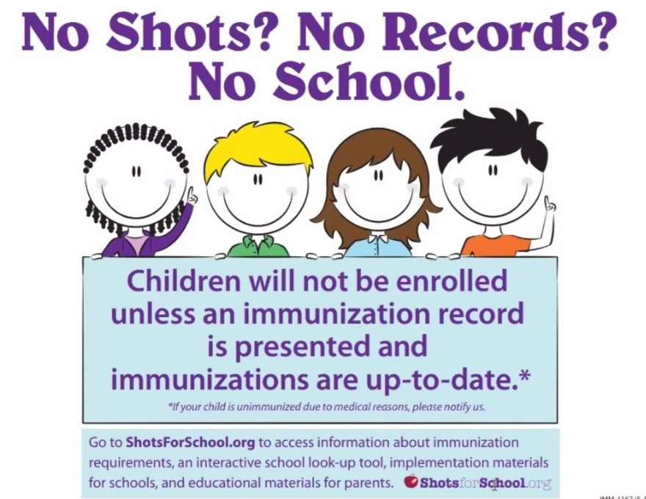
​Age When Admitted | ​Number of Doses Required of Each Immunization
​2 through 3 Months | ​1 Polio, 1 DTaP, 1 Hep B, 1 Hib
​4 through 5 Months | ​2 Polio, 2 DTaP, 2 Hep B, 2 Hib
​6 through 14 Months | ​2 Polio, 3 DTaP, 2 Hep B, 2 Hib
​15 through 17 Months | ​3 Polio, 3 DTaP, 2 Hep B, 1 Varicella  On or after 1st birthday: 1 Hib*, 1 MMR
​18 through 5 years | ​3 Polio, 4 DTaP, 3 Hep B, 1 Varicella  On or after 1st birthday: 1 Hib*, 1 MMR

*One Hib dose must be given on or after the 1st birthday regardless of previous doses. Required only for children younger than 5 years old.
DTaP= diphtheria toxoid, tetanus toxoid, andacellular pertussis vaccine Hib = Haemophilus influenzae, type B vaccine
Hep B = hepatitis B vaccine
MMR = measles, mumps, and rubella vaccine
Varicella = chickenpox vaccine

